WASABI / HumanEnerDIA / OVOS-EnMS

System Architecture Report

Version | 1.0
Date | 2026-06-08
Status | Final delivery documentation package
Purpose | Describe the implemented HumanEnerDIA / EnMS architecture and the OVOS-EnMS integration boundary.
Intended audience | Project managers, technical reviewers, deployment stakeholders, and external partners.

Evidence rule: Claims are tied to local source code, Docker configuration, SQL initialization files, and verified compose validation.

Table of Contents
1. Executive Summary
2. System Context
3. Runtime Services
4. Data And Message Flow
5. External And Internal Interfaces
6. OVOS-EnMS Integration
7. Security And Operational Considerations
8. Limitations And Assumptions
9. Evidence References

Executive Summary
HumanEnerDIA is implemented as a Docker Compose based industrial energy management stack. It combines an Nginx gateway, a static portal, FastAPI analytics APIs, PostgreSQL/TimescaleDB storage, MQTT telemetry, Node-RED ingestion, Grafana dashboards, a simulator, authentication services, a Rasa text chatbot path, and an optional OVOS-EnMS voice/natural-language assistant layer.
The OVOS-EnMS component is a separate assistant runtime that connects to the HumanEnerDIA-compatible analytics API. Its REST bridge does not calculate energy answers by itself; it forwards user queries to the OVOS messagebus, where the EnMS skill parses, validates, executes API calls, and formats responses.
Observed in code/config: The base stack is defined in docker-compose.yml. The full-stack release can add OVOS through scripts/release/docker-compose.ovos.yml or the OVOS repository compose file under /home/ubuntu/ovos-llm.

System Context
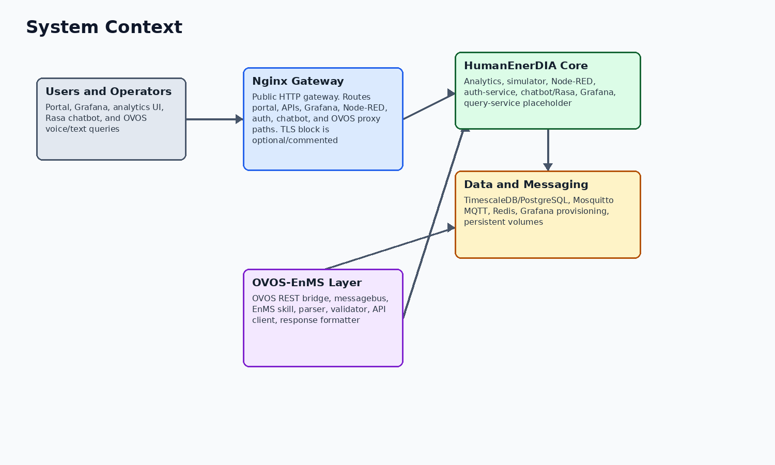
Figure 1. System context and product boundaries.
The system has three boundaries that must remain distinct in delivery documentation. HumanEnerDIA / EnMS is the energy management backend and visualization stack. OVOS-EnMS is the voice/natural-language assistant layer that integrates with the analytics API. The Rasa chatbot is a text-oriented help and knowledge path, not the same runtime as the OVOS skill.
Boundary | Included components | Evidence
HumanEnerDIA / EnMS | Nginx, portal, analytics, PostgreSQL/TimescaleDB, MQTT, Node-RED, Grafana, simulator, auth-service, Rasa/chatbot services | docker-compose.yml
OVOS-EnMS | OVOS runtime, REST bridge, messagebus, EnMS skill, parser, validator, API client, response formatter | /home/ubuntu/ovos-llm/enms-ovos-skill/enms_ovos_skill/__init__.py
External users/integrators | Browser users, API clients, OVOS clients, operators, WASABI release reviewers | README.md; docs/README.md; docs/OPERATIONS_RUNBOOK.md

Runtime Services
The base runtime service inventory below is taken from docker-compose.yml and verified by docker compose config --quiet during this documentation pass.
Service | Image or build context | External port/path | Responsibility | Healthcheck
nginx | nginx:1.25-alpine | 8080; 8443 mapped but HTTPS server block is optional/commented until certificates are configured | Public gateway, portal/static hosting, reverse proxy | Yes
postgres | timescale/timescaledb:latest-pg16 | 5433 | PostgreSQL with TimescaleDB extension and persistent data volume | Yes
mqtt | build ./mqtt | 1883, 9001 | Mosquitto telemetry broker with configured credentials | Yes
redis | redis:7-alpine | 6380 | Redis cache and Pub/Sub support for analytics event paths | Yes
simulator | build ./simulator | internal 8003 | FastAPI synthetic telemetry generator loaded from database machines | Yes
nodered | build ./nodered | 1881 | MQTT-to-database ingestion and automation flow runtime | Yes
grafana | grafana/grafana:10.2.0 | 3001, /grafana | Provisioned dashboards backed by PostgreSQL/TimescaleDB | Yes
analytics | build ./analytics | 8001, /api/analytics | FastAPI analytics, KPI, reports, ISO 50001, and OVOS proxy APIs | Yes
query-service | build ./query-service | 8002 | Reserved placeholder; healthcheck disabled and not a readiness signal | No
auth-service | build ./auth-service | 5500 | Flask auth, admin, contact, pilot/application APIs | Yes
rasa-actions | build ./chatbot/rasa | 5055 | Rasa custom action server | Yes
rasa | build ./chatbot/rasa | 5005 | Rasa NLU text chatbot server | Yes
chatbot | build ./chatbot | 5006 | Express backend and built chatbot frontend proxying to Rasa and OVOS | Yes

Data And Message Flow
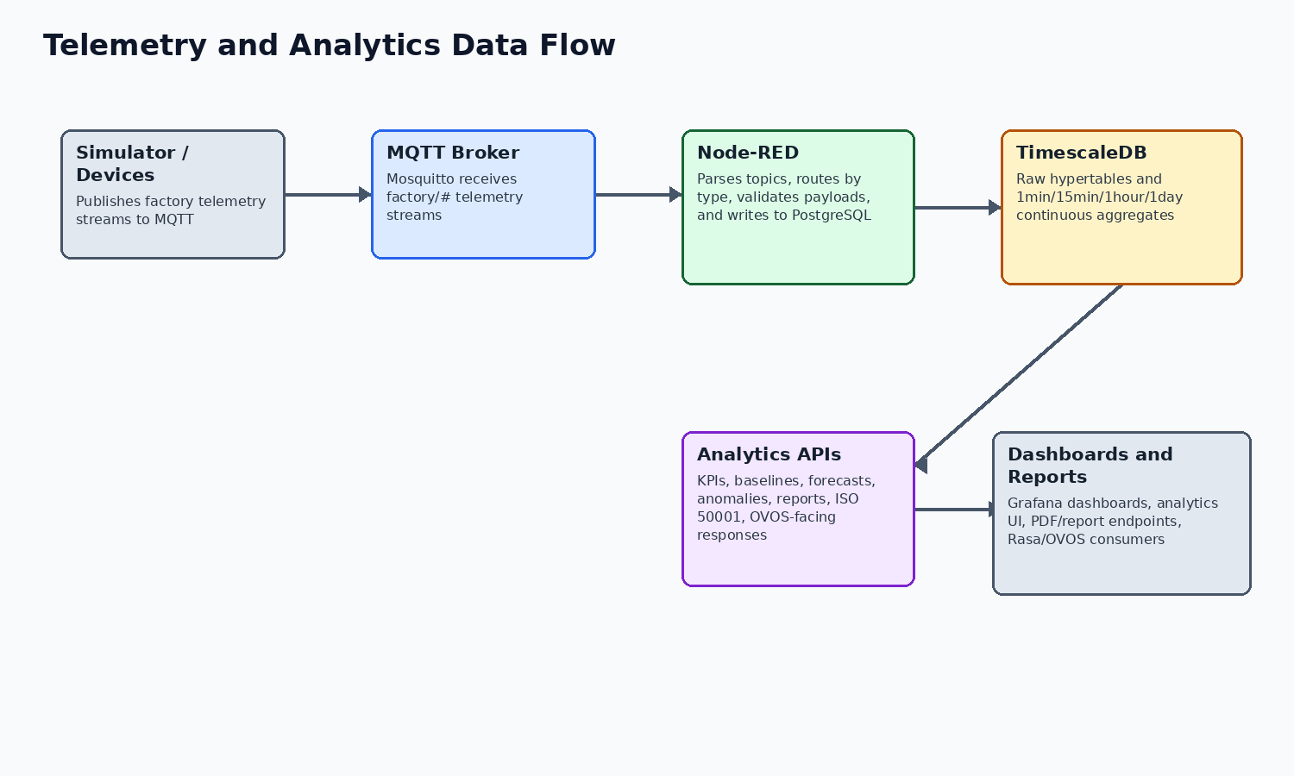
Figure 2. Telemetry ingestion and analytics data flow.
Synthetic factory data or external device data enters through MQTT. Node-RED subscribes to factory/#, parses the topic structure, routes by payload type, validates required fields, and writes energy, production, environmental, and status data into PostgreSQL.
TimescaleDB hypertables and continuous aggregates provide raw and aggregated time-series views. The analytics service reads from those tables and aggregate views to support KPIs, baselines, forecasts, anomalies, reports, Grafana dashboards, and OVOS-facing responses.
Stage | Observed implementation | Evidence
Telemetry source | simulator loads active machines from PostgreSQL and publishes MQTT messages for energy, production, environmental, status, and multi-energy boiler topics | simulator/main.py; simulator/api/routes.py; simulator/simulator_manager.py; simulator/mqtt_publisher.py
Broker | mqtt service exposes 1883 and websocket 9001 with credentials supplied through environment variables | docker-compose.yml
Ingestion | Node-RED flow includes Subscribe: factory/#, Parse Topic, Route by Type, Process Energy/Production/Environmental/Status, and PostgreSQL output nodes | nodered/data/flows.json; nodered/settings.js; nodered/package.json
Storage | energy_readings, production_data, and environmental_data are converted to TimescaleDB hypertables with continuous aggregates | database/init/02-schema.sql; database/init/03-timescaledb-setup.sql; database/init/04-functions.sql
Consumption | Analytics API, Grafana dashboards, portal, chatbot, and OVOS integration consume database-backed data | analytics/main.py

External And Internal Interfaces
External browser access normally enters through Nginx. Direct service ports are exposed for operations and development; production exposure should be restricted by firewall or reverse proxy policy.
Interface | Route or endpoint | Evidence/notes
Unified portal | http://<host>:8080 | Served by Nginx from portal/public
Grafana | http://<host>:8080/grafana | Sub-path proxy to Grafana with provisioned dashboards
Analytics UI | http://<host>:8080/analytics/ui/ | FastAPI-rendered analytics templates
Analytics API docs | http://<host>:8080/api/analytics/docs | Nginx proxy to analytics OpenAPI docs
Simulator docs | http://<host>:8080/api/simulator/docs | Nginx proxy to simulator OpenAPI docs
Node-RED | http://<host>:1881 or http://<host>:8080/nodered/ | Admin UI protected by Node-RED credentials
OVOS bridge | http://<host>:5000/health | Available when OVOS stack/overlay is deployed
Analytics health | Direct service path /api/v1/health; through Nginx analytics proxy /api/analytics/api/v1/health | analytics/main.py; nginx/conf.d/default.conf
OVOS proxy via EnMS | /api/ovos/* -> /api/v1/ovos/* | nginx/conf.d/default.conf; analytics/api/routes/ovos_voice.py
OVOS direct bridge | POST /query, POST /query/voice, GET /health | /home/ubuntu/ovos-llm/enms-ovos-skill/bridge/ovos_rest_bridge.py

OVOS-EnMS Integration
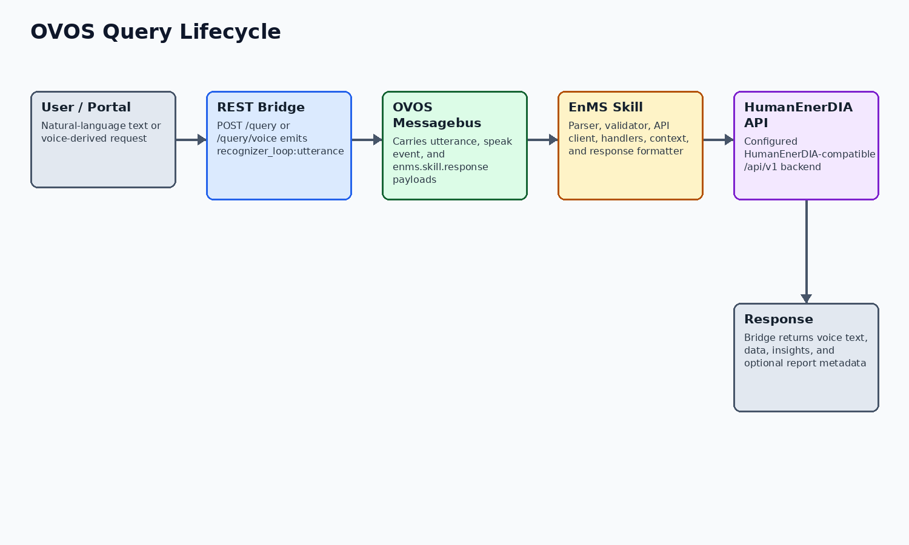
Figure 3. OVOS request and response lifecycle.
The OVOS bridge receives text queries through /query or /query/voice. It emits recognizer_loop:utterance to the OVOS messagebus and listens for speak and enms.skill.response events. The skill handles intent routing, context, validation, backend API calls, and deterministic response formatting.
HumanEnerDIA also exposes /api/v1/ovos/voice/query and /api/v1/ovos/voice/health as a proxy route from the analytics service to the OVOS bridge. This supports portal-side integration without making the portal responsible for OVOS messagebus details.

Security And Operational Considerations
The repository supports several operational controls, but public production hardening remains an operator responsibility. The setup helper creates .env from .env.example when needed and generates first-run secrets for database, Grafana, Node-RED, Redis, MQTT, JWT, and API key values.
Authentication is implemented by auth-service using bcrypt password hashing, JWT sessions, email verification and password reset flows, admin allow-listing from environment variables, session tracking, and audit tables. Node-RED has admin authentication configured through environment-provided credentials.
- Do not commit .env, generated secrets, runtime logs, database dumps, model caches, or Docker volumes.
- Restrict direct exposure of PostgreSQL, Redis, MQTT, Grafana, Node-RED, and service debug ports in production.
- Terminate TLS at Nginx or an upstream reverse proxy before internet-facing deployment.
- Rotate credentials before public use, especially any generated first-run secrets.

Limitations And Assumptions
The following items should be reviewed before stakeholder distribution. They are documented to avoid overstating the current implementation.
Item | Status
query-service | Placeholder only; Docker service exists, healthcheck disabled, and it is excluded from release readiness expectations.
Runtime verification | This documentation package records compose validation. Live health checks require a running deployment and are not implied unless run separately.
OVOS release artifact | The OVOS source tree may contain local GGUF model files, but release notes state optional GGUF weights are not bundled by default.
Third-party EnMS support | OVOS portability is through a HumanEnerDIA-compatible API or adapter/proxy, not zero-code support for arbitrary vendor APIs.
Reports V2 | V2 report code is implemented, but some service calculations use derived/proportional or placeholder values; final stakeholders should review report semantics before audit use.
Simulator inventory | The simulator code supports boiler in addition to compressor, HVAC, motor, pump, and injection molding. One simulator info response still lists five machine types.
Security posture | The codebase provides secret placeholders, generated first-run credentials, JWT/bcrypt auth, health checks, and hardening guidance. Public production exposure still requires operator DNS/TLS/firewall/credential work.

Evidence References
The table below lists the main local evidence used for this document. It is not a full file inventory; it identifies the sources behind the material claims.
Topic | Evidence
Runtime topology | docker-compose.yml
OVOS overlay | scripts/release/docker-compose.ovos.yml
Routing | nginx/nginx.conf; nginx/conf.d/default.conf
Database and KPIs | database/init/02-schema.sql; database/init/03-timescaledb-setup.sql; database/init/04-functions.sql
Analytics API | analytics/main.py
OVOS bridge and skill | /home/ubuntu/ovos-llm/enms-ovos-skill/bridge/ovos_rest_bridge.py; /home/ubuntu/ovos-llm/enms-ovos-skill/enms_ovos_skill/__init__.py
Compose validation | docker compose config --quiet returned success for /home/ubuntu/humanergy and /home/ubuntu/ovos-llm

